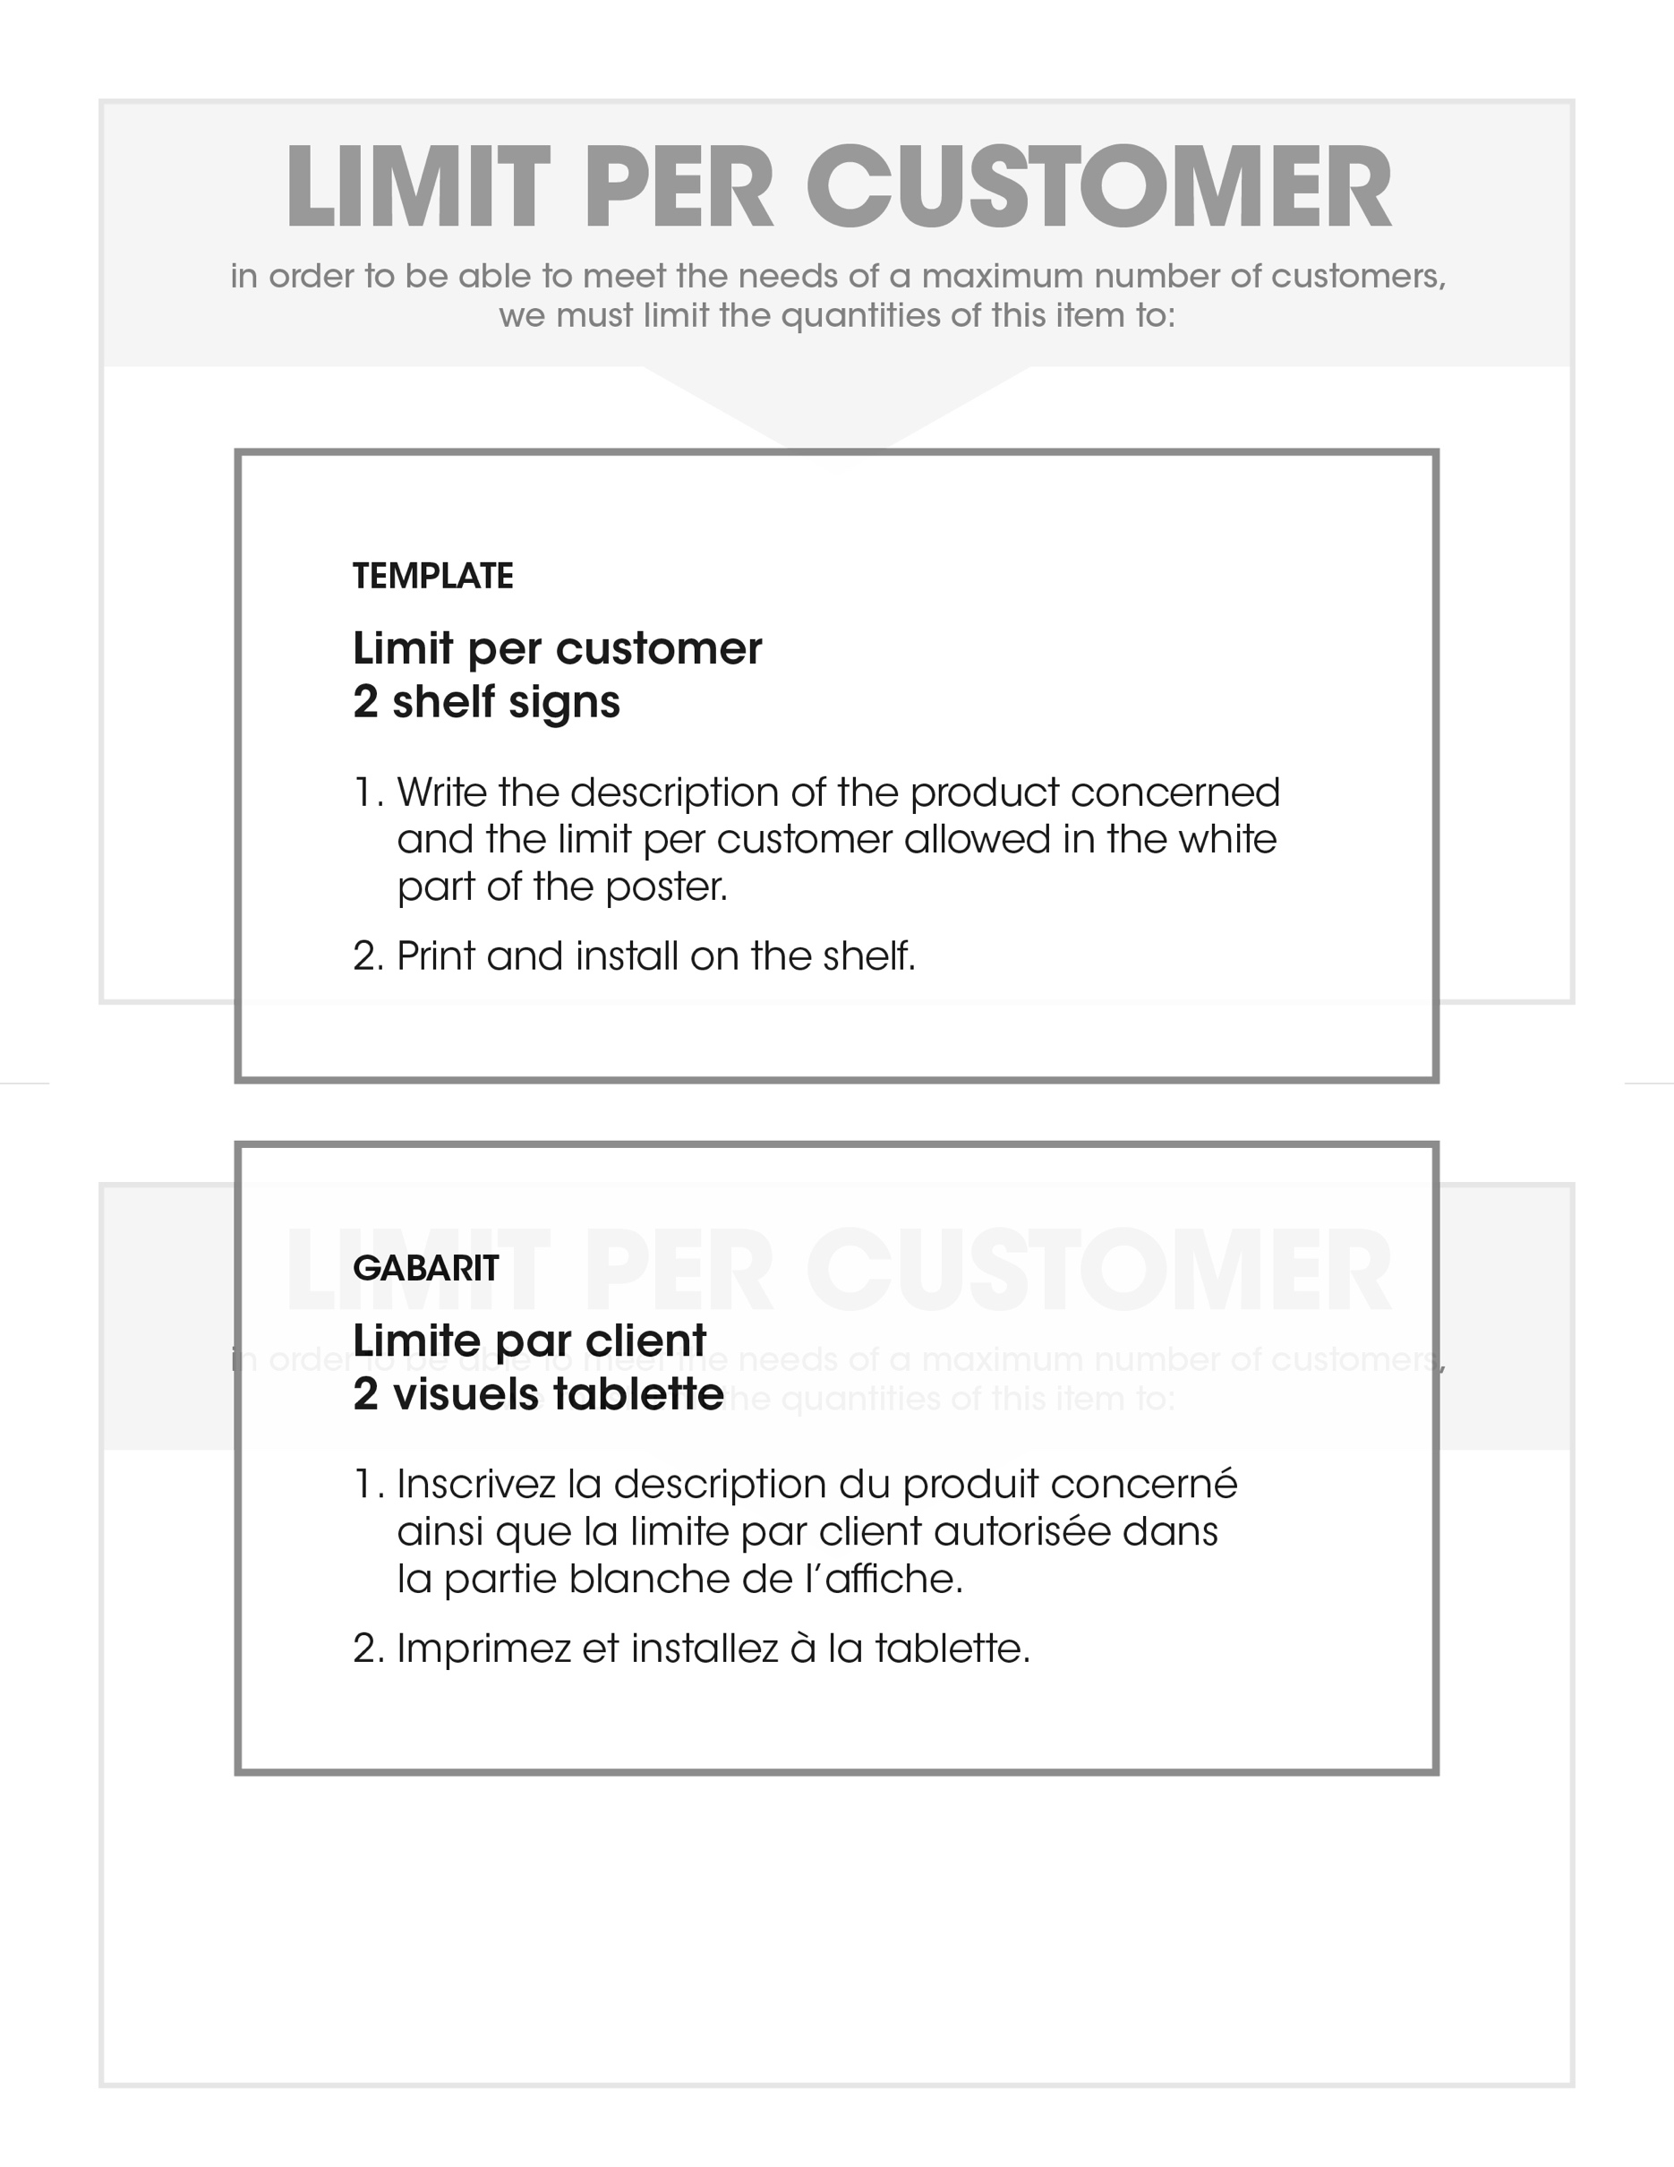
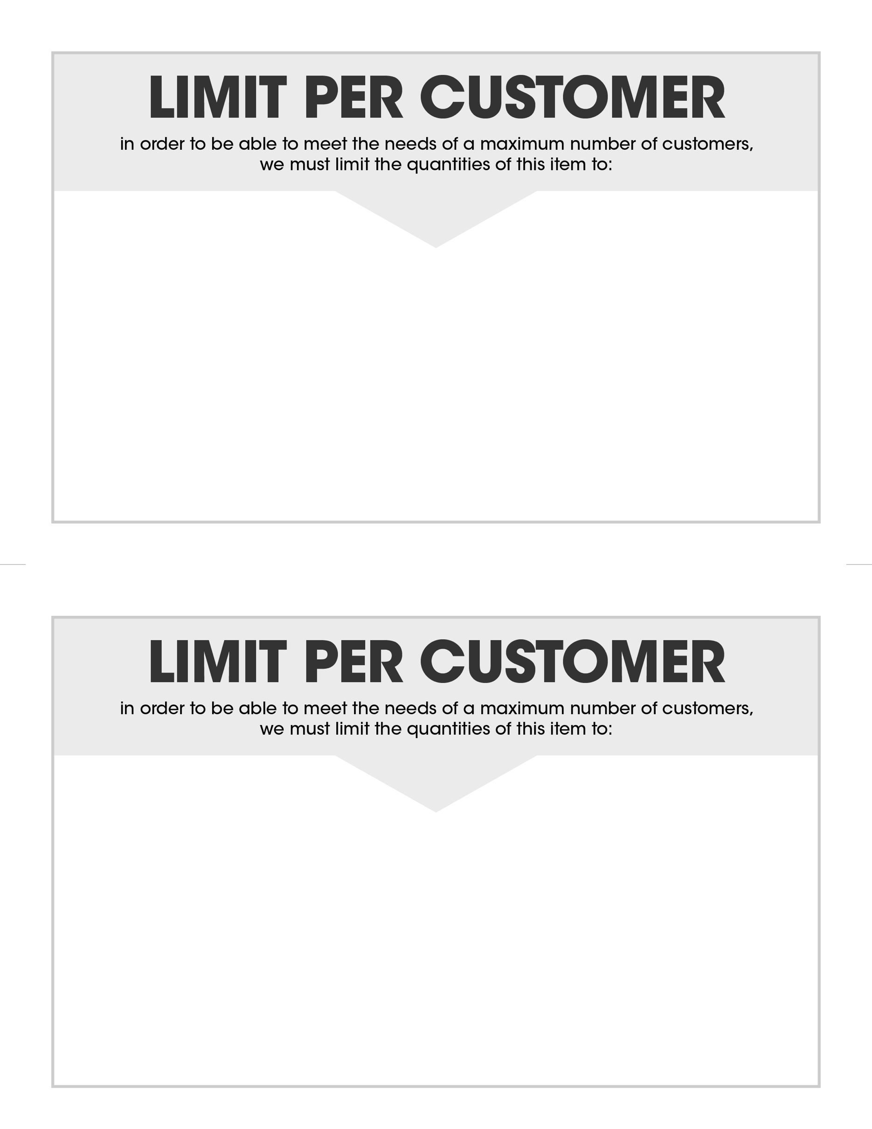
BRAND
DESCRIPTION
LIMIT OF #

BRAND
DESCRIPTION
LIMIT OF #

