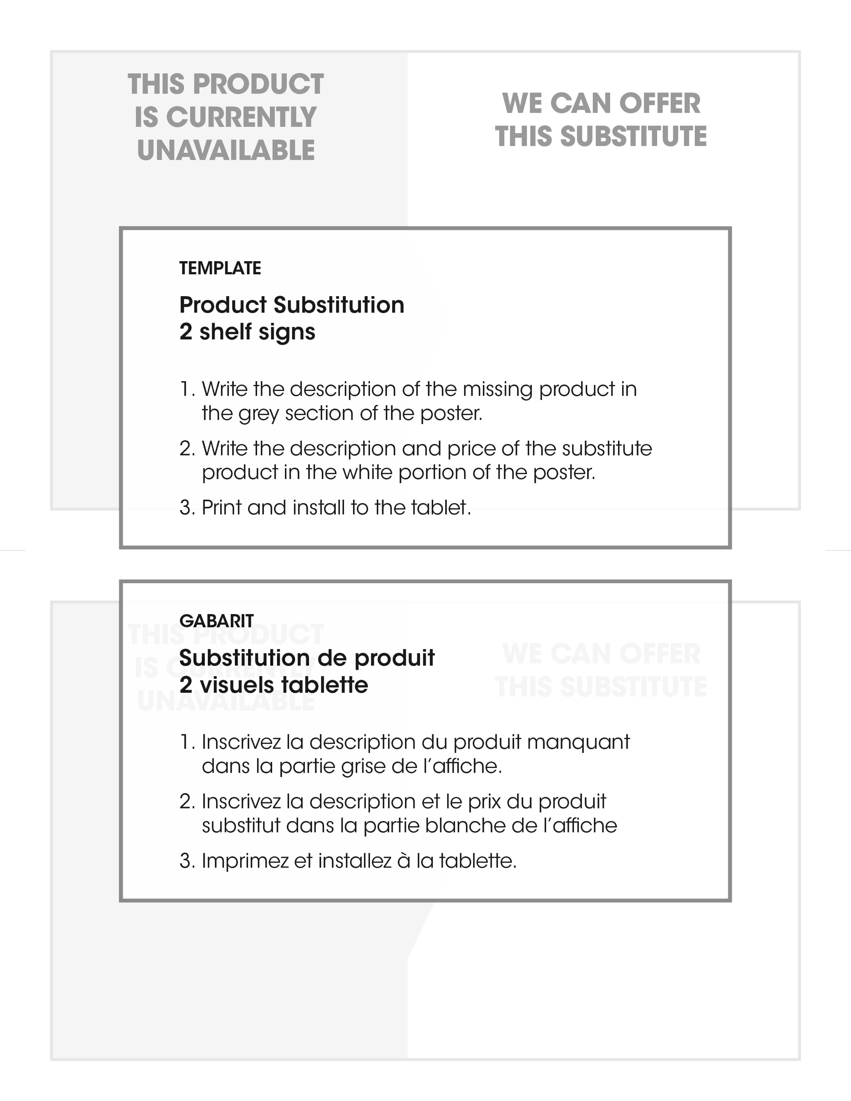
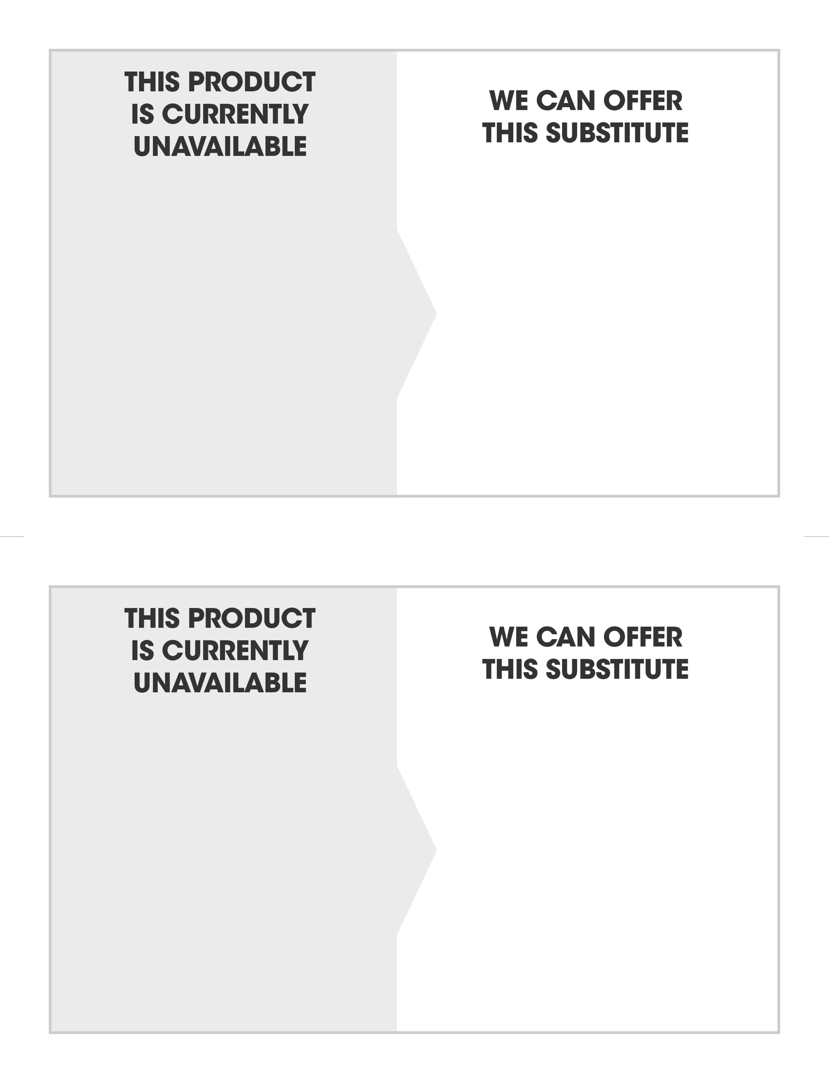
BRAND
DESCRIPTION
QUANTITY
BRAND
DESCRIPTION
QUANTITY
BRAND
DESCRIPTION
QUANTITY

BRAND
DESCRIPTION
QUANTITY

